Date: 12.09.2025
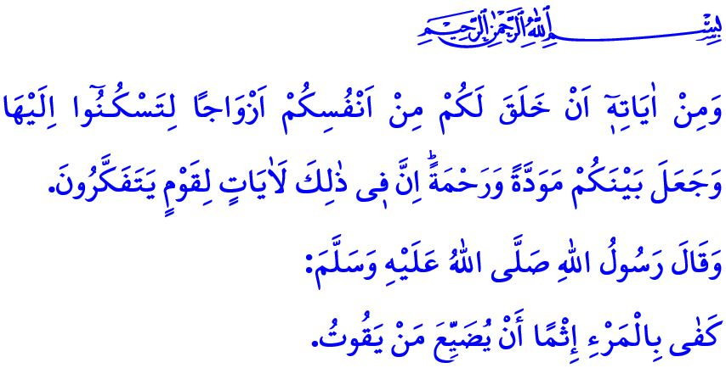
OUR PROPHET AND HIS FAMILY ETHICS
Honorable Muslims!
The guarantee of a peaceful society lies in a sound and strong family. A family is the home of joy and affection established through a lawful marriage between a man and a woman who have no religious impediment to their marriage. A family is the oldest and most enduring institution in human history. It is a unique school where faith, identity, and character are shaped, and where national and spiritual values are passed on to future generations. At the beginning of the khutbah, I recited the verse in which our Almighty Lord declares: “And one of His signs is that He created for you spouses from among yourselves so that you may find comfort in them. And He has placed between you compassion and mercy. Surely in this are signs for people who reflect.” In light of this commandment, the family is a sanctuary of love and respect, compassion and mercy.
Dear Believers!
We have learnt all the beauties and subtleties of family ethics from our Prophet (saw). The Messenger of Allah (saw) was extremely gentle and kind toward his family. There was gentleness in all his words and actions. He never hurt the heart of any member of his family, nor spoke harshly to them. The Messenger of Allah (saw) always expressed his love for his wife, Khadijah, saying, “I was sustained by her love.” With the hadith, “You will surely earn reward for every expense you make for your family seeking the pleasure of Allah,” he regarded every sacrifice made for the family as an act of goodness that earns Allah’s pleasure.
Esteemed Muslims!
When families stray from the moral values set forth by the Qur’an and Sunnah, they are left longing for peace and happiness. Regrettably, today, certain forces targeting the family seek to distance women from the sacred role of motherhood, men from the sacred role of fatherhood, and to weaken the roles of both within the family. Perversions that Islam has forbidden and which are contrary to human nature are being presented as innocent under the guise of civil partnerships; cohabitation without marriage is portrayed as normal, while marriage itself is depicted as a burden and a hardship. Yet, to marry and to form a family is the commandment of Allah, the Sunnah of our Prophet, and the requirement of human nature. It is essential for the continuation of lineage and the nation. The Messenger of Allah (saw) encouraged marriage in a hadith, saying: “Marriage is the best way to avert the eyes from what is forbidden and to preserve chastity.”
Dear Believers!
The paths leading to adultery, which destroy chastity and modesty and corrupt generations and society, must not be legitimized; nudity and exhibitionism should not be presented as a natural part of life. Alcohol, gambling, and substance addiction must not be portrayed as normal; distorted relationships and divorces, anger, and violence should not be presented as commonplace or acceptable. It must not be forgotten that adultery, alcohol, and gambling are among the major sins prohibited by our religion. Our Almighty Lord’s warnings regarding these matters are very clear: “Do not go near adultery. It is truly a shameful deed and an evil way.”
Dear Muslims!
Today, the institution of the family is under siege by global lobbies, interest groups, and imperialist powers to a degree unprecedented in history. These forces of evil have made it their aim to weaken family bonds, leave generations without identity and character, and sever them from their core values. In such circumstances, establishing, protecting, and strengthening the family is not merely an individual responsibility but a religious, moral, and human duty for every person of faith, conscience, and reason. Indeed, in the hadith I recited at the beginning of the khutbah, our Prophet (saw) says: “Neglecting one’s responsibilities towards one’s family is sufficient as a sin for a person.”
Dear Believers!
In this time when family values are being undermined, it is incumbent upon us to recognize the worth of our families—our paradise on earth, our fortified stronghold, and our final refuge. In family life, it is essential to uphold the boundaries of what is halal and haram set by Allah and follow the exemplary character of our Prophet (saw). By adhering to the commandment of our Almighty Lord, “Bid your people to pray, and be diligent in ˹observing˺ it,” our duty is to strive to instill a consciousness of worship within our family. It is to facilitate marriages, which are the foundation of the family, and to encourage our youth to marry. It is not to squander the quality time we should spend with our family in front of the television or on our phones. It is to keep communication within the family alive. It is to prioritize the emotional needs of family members. It is not to deprive our children of the warmth, love, and attention of the family.

I would like to conclude this Friday’s khutbah with the supplication of the Messenger of Allah (saw): “O Allah, Lord of all things! Make me and my family among those who are sincerely devoted to You in this world and the Hereafter.”

Rum, 30/21.
Muslim, Fadha’il al-Sahaba, 75.
Bukhari, Jana’iz, 36; Muslim, Zakat, 48.
Bukhari, Nikah, 3; Muslim, Nikah, 1.
Isra, 17/32.
Abu Dawud, Zakat, 45.
Ta-Ha, 20/132.
Abu Dawud, Witr, 25. General Directorate of Religious Services

